CURRICULUM VITAE

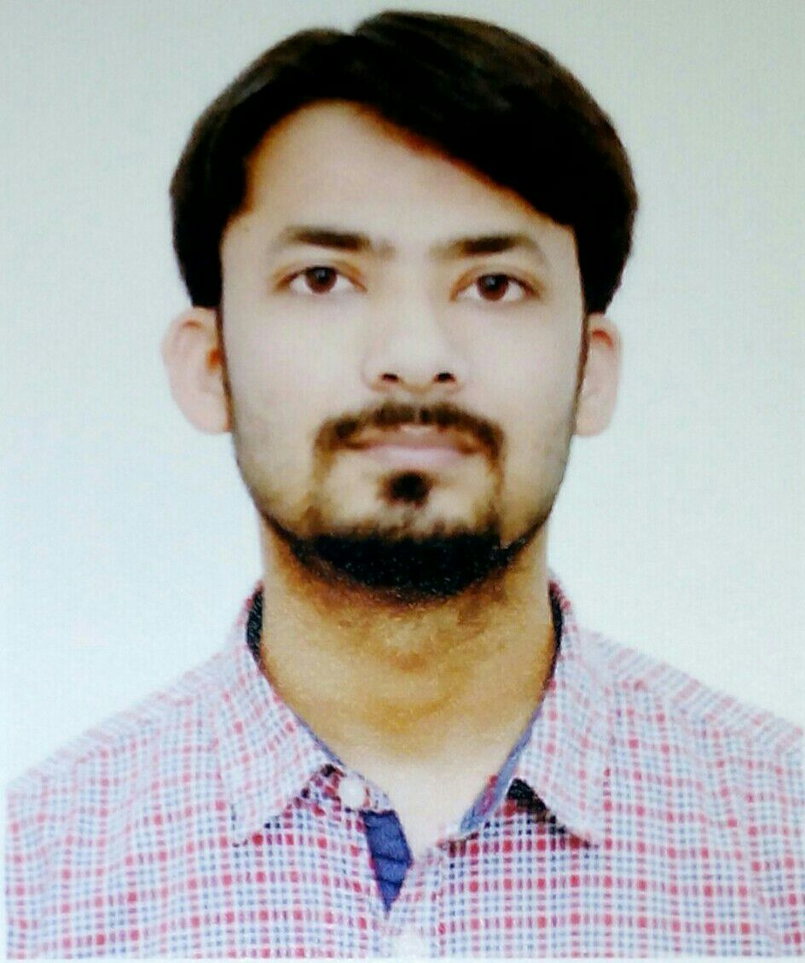
RAJESH SINGH
Ward No. 59, Top Paloura, Jammu.
Mobile No: - 8130249565, 9871859611
Email: - RAJESHSNGH94@GMAIL.COM

Objective

To work on a challenging job profile which provides s an opportunity to enhance my technical skills and knowledge, this could provide me an insight into new aspects so that it would be helping for my career.

Education

- 10th from JKBOSE.
- BPP from IGNOU.
- BSc. IT from KUVEMPU University.
- 11/2 year Diploma in Software Engineering from NIIT.

Work Experience
- 2 months as a data-entry operator.
- 1 year as a customer care executive in AITPL.
- 6 months as an auditor in FIT&FINE Pharmacy.
- 2 years as a Branch Manager in FIT&FINE Pharmacy.

Extra Curricular Activities

- Participated and won prizes in sports competitions in the school.
- Organize and participate in many debates in School.
- Participated in different types of awareness rallies.

Personality Strengths
- Work with positive attitude to contribute the healthy functioning of the organization.
- Self-Confident and Great Patience.
- Quick Learner with Ability to Grasp New Things.
- Ability to Work in Both Independent & Team Work.

Personal Details:
Date of Birth : 08/02/1991
Father : Sh. Balwan Singh
Mother : Smt.Koushalya Manhas
Language known : Dogri, Hindi and English
Nationality : Indian
Marital status : Unmarried

Declaration
I do hereby declare that the information given above is true to the best of my knowledge and belief.

Date: 07/09/2016
Place: Model Town, Delhi
RAJESH SINGH

